1.0 Overview
LEDs used in the previous revisions of in-pavement taxiway edge LED (ITEL) fixtures have been obsoleted by the manufacturer. Depending on color and LED drive currents other suitable LEDs are needed to replace the old. In some cases these new LEDs will need to be driven at a different current and will need the power supply to be replaced as well.
Below is detailed guidance on how to replace the parts.
Section 2.1, 2.2 & 2.3 will show you where to find your existing light engine & power supply part numbers.
Section 3 will show you what light engine and & power supply number to order to replace the existing part.

2.0 Identification Guidance for ITEL Power supplies and LED optical assys
2.1 Identification of 44A6355/XXX light engine and 44A6344/XX power supply :
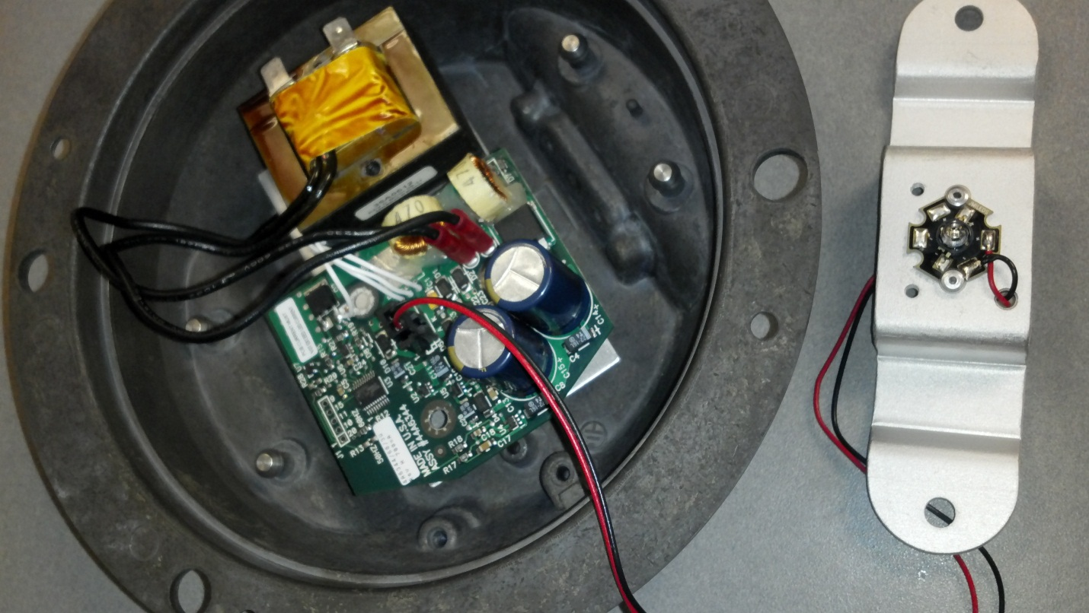
44A6344/XX part number on power PCB
44A6355/XX part number on far side of light engine

2.2 Identification of 44A6629/XX light engine and 44A6596/X power supply :
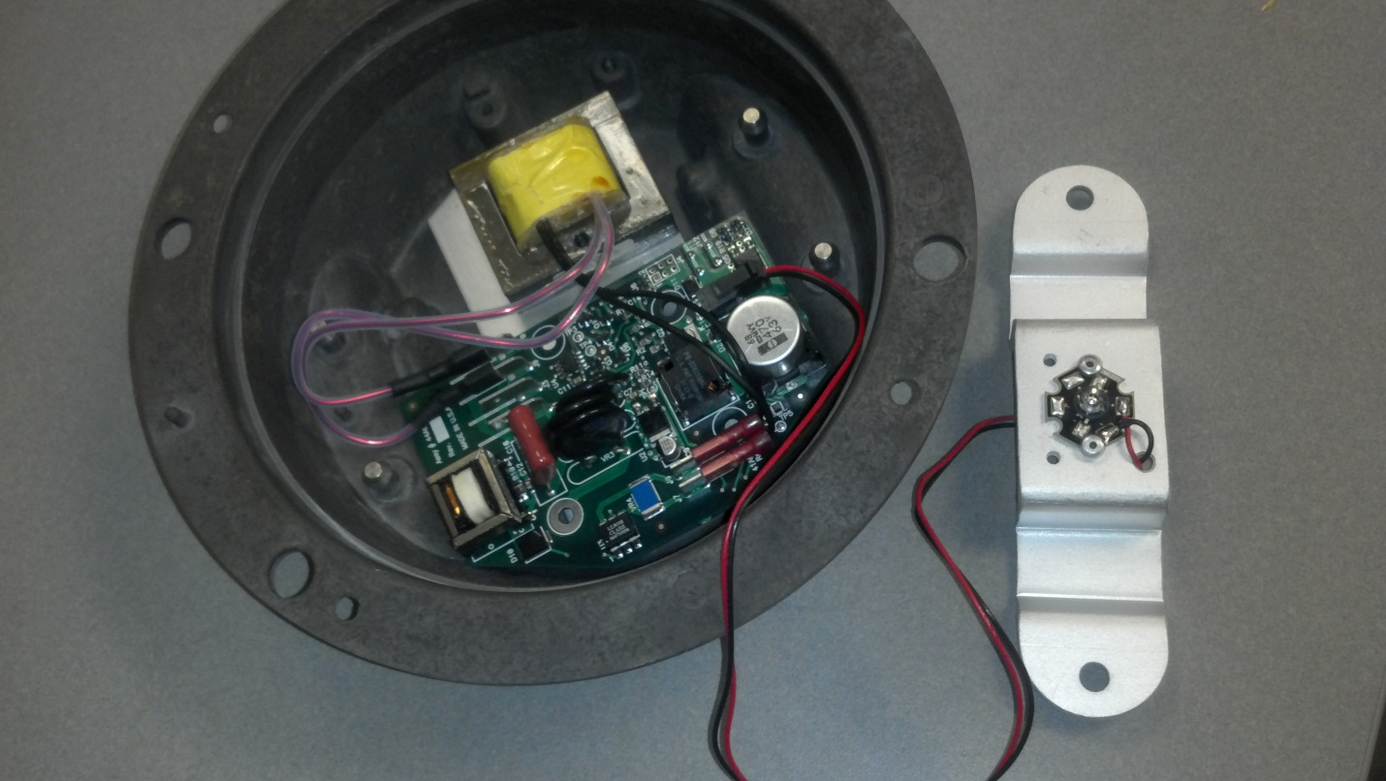
44A6596/X part number on far side of power PCB

44A6629/XX part number on far side of light engine

2.3 Identification of 44A7177/XX light engine and 44A7197/XX/X power supply :
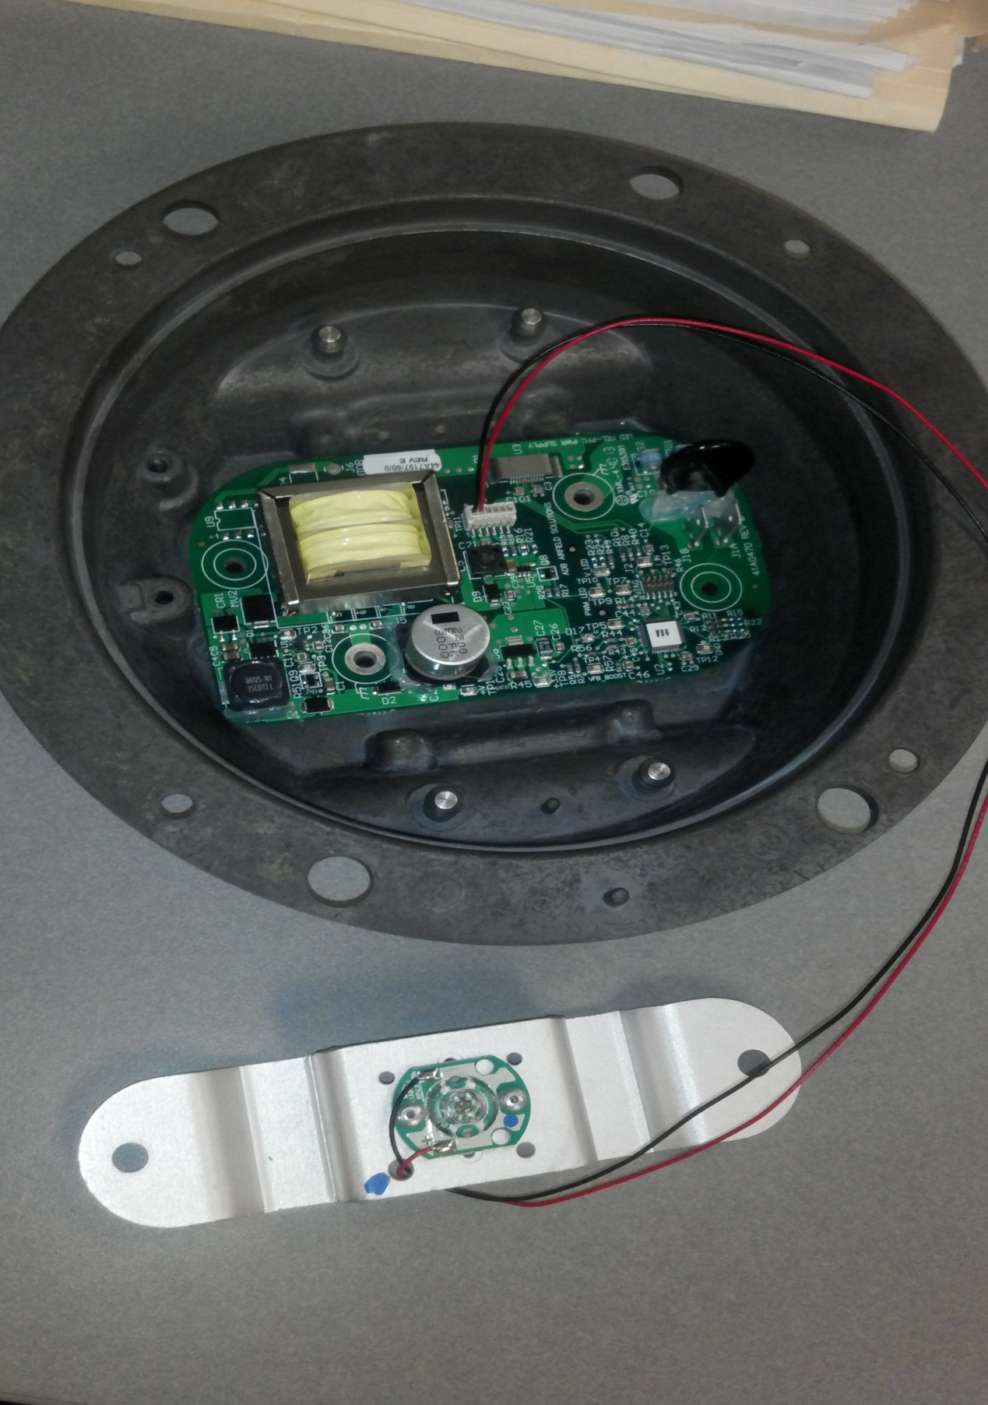
44A7197/XX/X power supply part number
44A7177/XX part number on far side of light engine

3.0 When ordering spare parts for ITEL fixtures check the Replacement Guide below for details on what parts to order and what parts to replace.
Table 1.0: ITEL Light Engine Replacement Guidance
If you have to replace LED light engine part number and none are left in stock: | Replacement Guidance
 | Order LED light engine part number: | Also order and replace LED Transformer/Power Supply PCB with:
44A6355/10 | 44A7177/10 | 44A7197/60/0 for 60Hz  44A7197/50/0 for 50 Hz
44A6355/11 | 44A7177/11 | 44A7197/60/0 for 60Hz  44A7197/50/0 for 50 Hz
44A6355/20 | 44A7177/50 | 44A7197/60/0 for 60Hz  44A7197/50/0 for 50 Hz
44A6355/21 | 44A7177/51 | 44A7197/60/0 for 60Hz  44A7197/50/0 for 50 Hz
44A6355/40 | 44A7177/40 | 44A7197/60/0 for 60Hz  44A7197/50/0 for 50 Hz
44A6355/41 | 44A7177/41 | 44A7197/60/0 for 60Hz  44A7197/50/0 for 50 Hz
44A6355/70 | 44A7177/20 | 44A7197/60/0 for 60Hz  44A7197/50/0 for 50 Hz
44A6355/71 | 44A7177/21 | 44A7197/60/0 for 60Hz  44A7197/50/0 for 50 Hz
44A6629/10 | 44A7177/10 | 44A7197/60/0 for 60Hz non-monitored  44A7197/50/0 for 50Hz non-monitored  44A7197/60/0 60Hz & monitoring  44A7197/60/0 50Hz & monitoring
44A6629/11 | 44A7177/11 | 44A7197/60/0 for 60Hz non-monitored  44A7197/50/0 for 50Hz non-monitored  44A7197/60/0 60Hz & monitoring  44A7197/60/0 50Hz & monitoring
44A6629/20 | 44A7177/20 | 44A7197/60/0 for 60Hz non-monitored  44A7197/50/0 for 50Hz non-monitored  44A7197/60/0 60Hz & monitoring  44A7197/60/0 50Hz & monitoring
44A6629/21 | 44A7177/21 | 44A7197/60/0 for 60Hz non-monitored  44A7197/50/0 for 50Hz non-monitored  44A7197/60/0 60Hz & monitoring  44A7197/60/0 50Hz & monitoring
44A6629/30 | 44A7177/30 | 44A7197/60/0 for 60Hz non-monitored  44A7197/50/0 for 50Hz non-monitored  44A7197/60/0 60Hz & monitoring  44A7197/60/0 50Hz & monitoring
44A6629/31 | 44A7177/31 | 44A7197/60/0 for 60Hz non-monitored  44A7197/50/0 for 50Hz non-monitored  44A7197/60/0 60Hz & monitoring  44A7197/60/0 50Hz & monitoring
44A6629/40 | 44A7177/40 | 44A7197/60/0 for 60Hz non-monitored  44A7197/50/0 for 50Hz non-monitored  44A7197/60/0 60Hz & monitoring  44A7197/60/0 50Hz & monitoring
44A6629/41 | 44A7177/41 | 44A7197/60/0 for 60Hz non-monitored  44A7197/50/0 for 50Hz non-monitored  44A7197/60/0 60Hz & monitoring  44A7197/60/0 50Hz & monitoring
44A6629/50 | 44A7177/50 | 44A7197/60/0 for 60Hz non-monitored  44A7197/50/0 for 50Hz non-monitored  44A7197/60/0 60Hz & monitoring  44A7197/60/0 50Hz & monitoring
44A6629/51 | 44A7177/51 | 44A7197/60/0 for 60Hz non-monitored  44A7197/50/0 for 50Hz non-monitored  44A7197/60/0 60Hz & monitoring  44A7197/60/0 50Hz & monitoring
44A6629/60 | 44A7177/60 | 44A7197/60/0 for 60Hz non-monitored  44A7197/50/0 for 50Hz non-monitored  44A7197/60/0 60Hz & monitoring  44A7197/60/0 50Hz & monitoring
44A6629/61 | 44A7177/61 | 44A7197/60/0 for 60Hz non-monitored  44A7197/50/0 for 50Hz non-monitored  44A7197/60/0 60Hz & monitoring  44A7197/60/0 50Hz & monitoring
44A6629/70 | 44A7177/10 | 44A7197/60/0 for 60Hz non-monitored  44A7197/50/0 for 50Hz non-monitored  44A7197/60/0 60Hz & monitoring  44A7197/60/0 50Hz & monitoring
44A6629/71 | 44A7177/11 | 44A7197/60/0 for 60Hz non-monitored  44A7197/50/0 for 50Hz non-monitored  44A7197/60/0 60Hz & monitoring  44A7197/60/0 50Hz & monitoring
44A7177/10 | 44A7177/10 | There is no need to replace power supply if OK
44A7177/11 | 44A7177/11 | There is no need to replace power supply if OK
44A7177/20 | 44A7177/20 | There is no need to replace power supply if OK
44A7177/21 | 44A7177/21 | There is no need to replace power supply if OK
44A7177/30 | 44A7177/30 | There is no need to replace power supply if OK
44A7177/31 | 44A7177/31 | There is no need to replace power supply if OK
44A7177/40 | 44A7177/40 | There is no need to replace power supply if OK
44A7177/41 | 44A7177/41 | There is no need to replace power supply if OK
44A7177/50 | 44A7177/50 | There is no need to replace power supply if OK
44A7177/51 | 44A7177/51 | There is no need to replace power supply if OK
44A7177/60 | 44A7177/60 | There is no need to replace power supply if OK
44A7177/61 | 44A7177/61 | There is no need to replace power supply if OK
44A7177/70 | 44A7177/70 | There is no need to replace power supply if OK
44A7177/80 | 44A7177/80 | There is no need to replace power supply if OK
44A7177/90 | 44A7177/90 | There is no need to replace power supply if OK
44A7177/A0 | 44A7177/A0 | There is no need to replace power supply if OK
44A7177/B0 | 44A7177/B0 | There is no need to replace power supply if OK

Table 2.0: ITEL Transformer/Power Supply PCB Replacement Guidance
If you have to replace LED Transformer/Power Supply PCB number: | Replacement Guidance
 | Order LED Transformer/Power Supply PCB number: | Notes
44A6344/60 | 44A6354/60 Inner Pan Sub-assy | There is no need to replace light engine(s) if it is OK
44A6344/50 | 44A6354/50 Inner Pan Sub-assy | There is no need to replace light engine(s) if it is OK
44A6344/60/1W | 44A6354/70 Inner Pan Sub-assy | There is no need to replace light engine(s) if it is OK
44A6344/60/3W | 44A6354/80 Inner Pan Sub-assy | There is no need to replace light engine(s) if it is OK
44A6344/50/1W | 44A6354/90 Inner Pan Sub-assy | There is no need to replace light engine(s) if it is OK
44A6596 | 44A6612/11 Inner pan assy 60Hz with monitoring  44A6612/21 Inner pan assy  50Hz with monitoring | There is no need to replace light engine(s) if it is OK
44A6596/1 | 44A6638/11 852N Inner pan with monitoring | There is no need to replace light engine(s) if it is OK
44A6596/1/2 | 44A6638/10 852N Inner pan without monitoring | There is no need to replace light engine(s) if it is OK
44A6596/2 | 44A6612/11 Inner pan assy 60Hz without monitoring  44A6612/21 Inner pan assy  50Hz without monitoring | There is no need to replace light engine(s) if it is OK
44A7197/60/0 | 44A7197/60/0 | There is no need to replace light engine(s) if it is OK
44A7197/50/0 | 44A7197/50/0 | There is no need to replace light engine(s) if it is OK
44A7197/60/1 | 44A7197/60/1 | There is no need to replace light engine(s) if it is OK
44A7197/50/1 | 44A7197/50/1 | There is no need to replace light engine(s) if it is OK

